News Release — Neos Dance Theatre — March 12, 2019

Contact for media:
Bobby Wesner, Neos co-founder and artistic director: info@neosdancetheatre.org or 330-595-4650

Hi-res photos and additional information about the participating artists:
\www.neosdancetheatre.org/madeinashland or can be emailed directly to you.

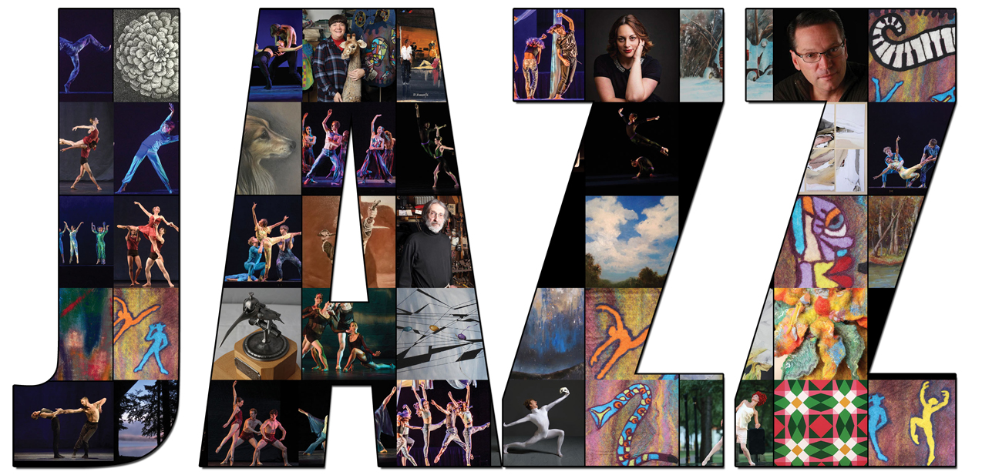

M.A.D.E. in Ashland returns April 6 with jazz in the spotlight

Ashland, OH — M.A.D.E. in Ashland is returning for a second year, this time shining the spotlight on jazz with a multi-media performance on Saturday, April 6, 7:30 p.m. at Archer Auditorium.

Neos Dance Theatre will share the Archer stage with local jazz musicians and works by visual artists — all with roots in Ashland County.

Among them is acclaimed jazz pianist Chip Stephens, a graduate of Ashland High School. A longtime professor of jazz piano at the University of Illinois, Stephens can be heard on nearly 80 records and compact discs as a sideman and bandleader.

He has performed on four continents with some of the most prestigious names in jazz, including Maynard Ferguson, Benny Golson, The Woody Herman Orchestra, Charlie Haden, Bill Kirchner, Ernie Krivda, Joe Lovano, Tito Puente, and Arturo Sandoval.

Kelly Knowlton, local favorite and Ashland University graduate, with her band, featuring Ashland percussionist Steve Berry, will perform jazz standards with a twist on the originals to revive a set performed with Neos earlier this season in Mansfield at Ballet @ the Brickyard.

Ashland textile artist Barbara Morejon has created unique costumes for some of the dancers, basing them on photographs from the Jazz Age. Images of other works by Morejon and Ashland metalsmith Barry Wheeler will be projected onto screens during the performance.

M.A.D.E. in Ashland (an acronym for Music, Art, Dance, and Education) will also showcase three ensembles from Ashland High School: the Ashland Jazz Band under direction of Neil Ebert, Sing and Swing under the direction of Kimberly Wolbert, and the low brass section of the Ashland Arrows Marching Band under the direction of Marty Kral.

Accompanied by the Sing and Swing troupe and tipping her hat to the roots of jazz dance in the Ashland area, Sarah Cyders, the artistic director of Ashland Regional Ballet, will perform Tuxedo Junction. Hellie Schussler, founder of Opus II Dance Studio and Ashland Regional Ballet, originated the solo work.

In the week before the M.A.D.E. in Ashland performance, Neos Dance Theatre and many of the guest artists will be in residence at Ashland High School to work closely with students from throughout Ashland County in master classes, rehearsals and performances. Dr. Doug Marrah, the superintendent of Ashland City Schools, is coordinating the residency with superintendents from the Mapleton, Hillsdale and Loudonville school districts.

"The level of music education and performance excellence I see coming out of the Ashland schools is outstanding", says Bobby Wesner, Neos’ artistic director and the choreographer and producer for M.A.D.E. in Ashland.

"That makes it so easy to maintain the level of excellence that Neos is known for while offering students a unique opportunity to perform alongside working professional artists, dancers, musicians and technical crew members."

In addition to the public performance and in-school residency, area artists have been paired with local businesses through Ashland to highlight their artwork throughout the month of March. For a list of venues and artists, visit the Neos Dance Theatre website www.neosdancetheatre.org

Tickets for M.A.D.E. in Ashland are $18 general seating, $15 senior pricing w/ID (62 and over), and $10 for students. They are available at www.neosdancetheatre.org/madeinashland.
#

